**DEPLOYMENT OF MICROSOFT AZURE COMPUTE WORKLOAD VIA POWERSHELL**

**Task Given:**

Pick an appropriate Windows Server image to support Hotpatching.

Pick an appropriate size for a small IIS server (1-5 users, static website) with very low average CPU.

Deploy within the Australia East region.

Use an appropriate subnetting scheme for approximately 20 related machines.

Make sure the machine is secure with only secure public web access.

Create and apply an appropriate backup policy.

Solution:

**According to the given task,I have connected Azure account to Powershell by using commands:**

* **Install-Modue Az**
* **Import-Module Az**
* **Connect -AzAccount**

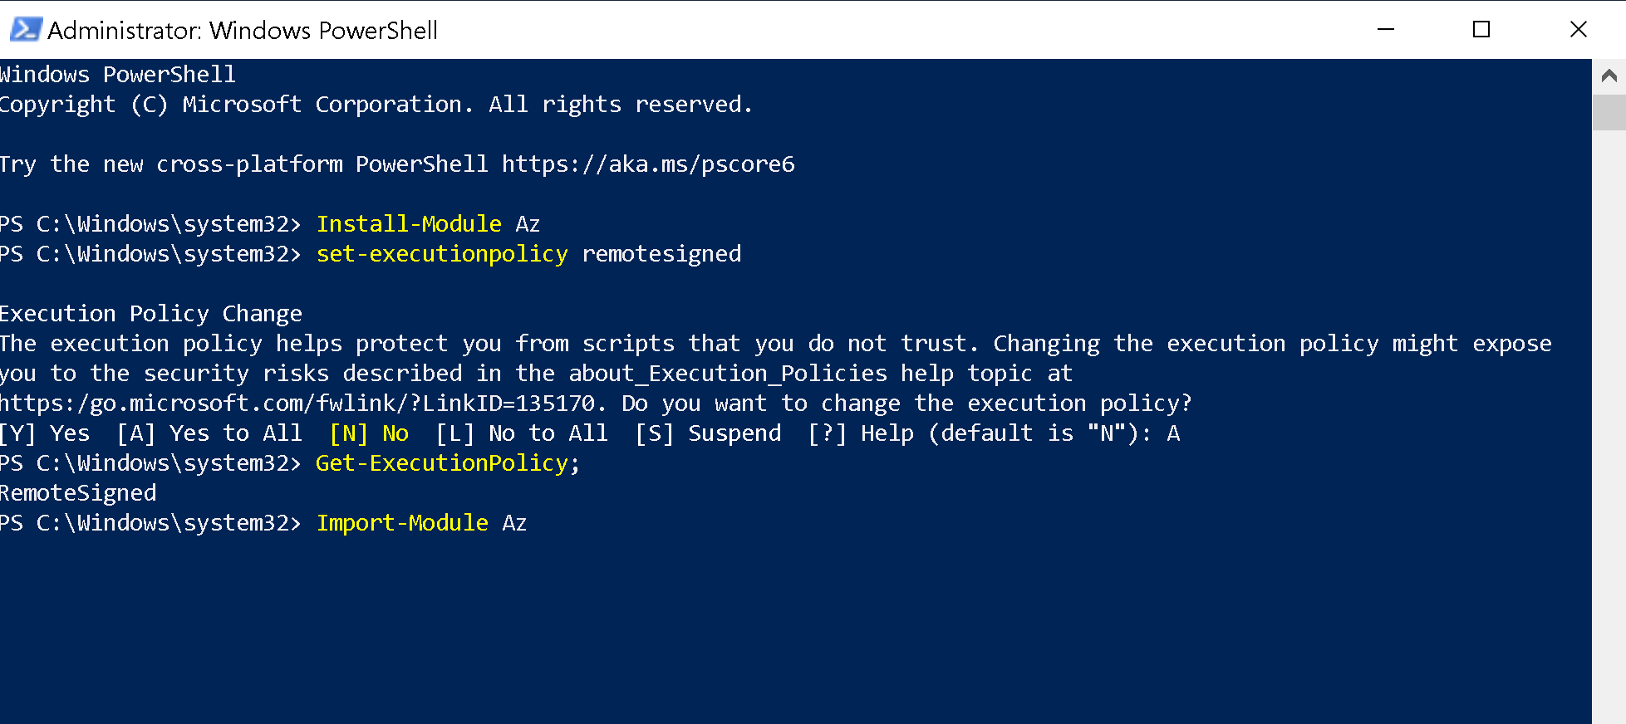

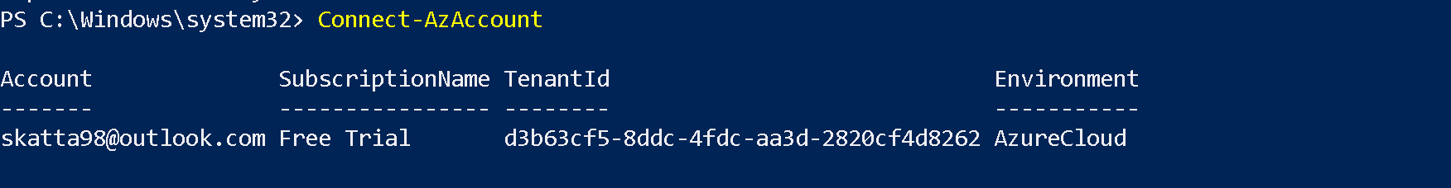

**After connecting the Azure account to powershell ,I have created a resource group with naming convention ‘FWAUERG’ ,Virtual machine ‘FWAUEVM1’ in Virtual Network ‘FWAUEVNET1’ and with Subnet ‘FW-Subnet-1’ with image as ‘Win2019Datacenter’ and allocated size ‘Standard_DS1_v2’and created Network Security Group ’FW-NSG’ and Pubilc IP address ‘FW-PIP’ in ports ‘443,3389’**

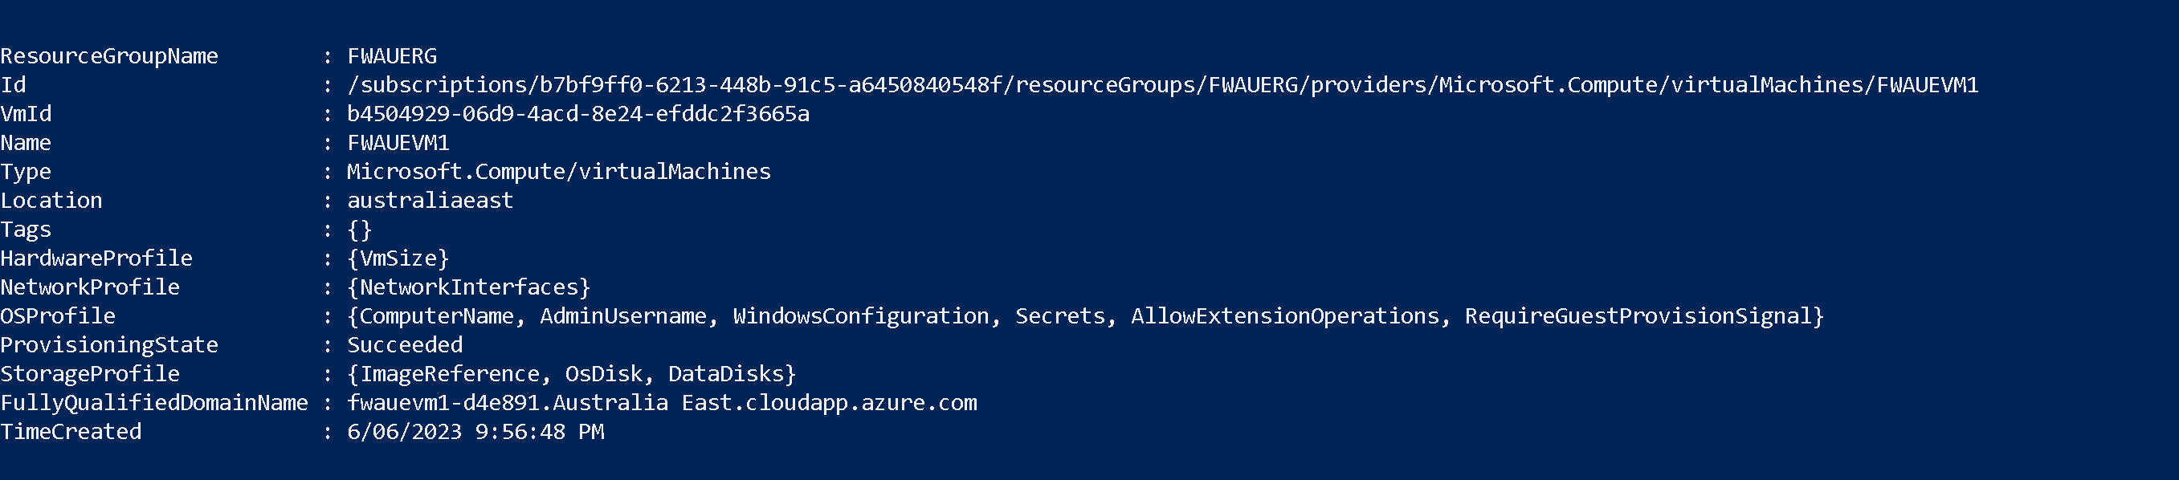

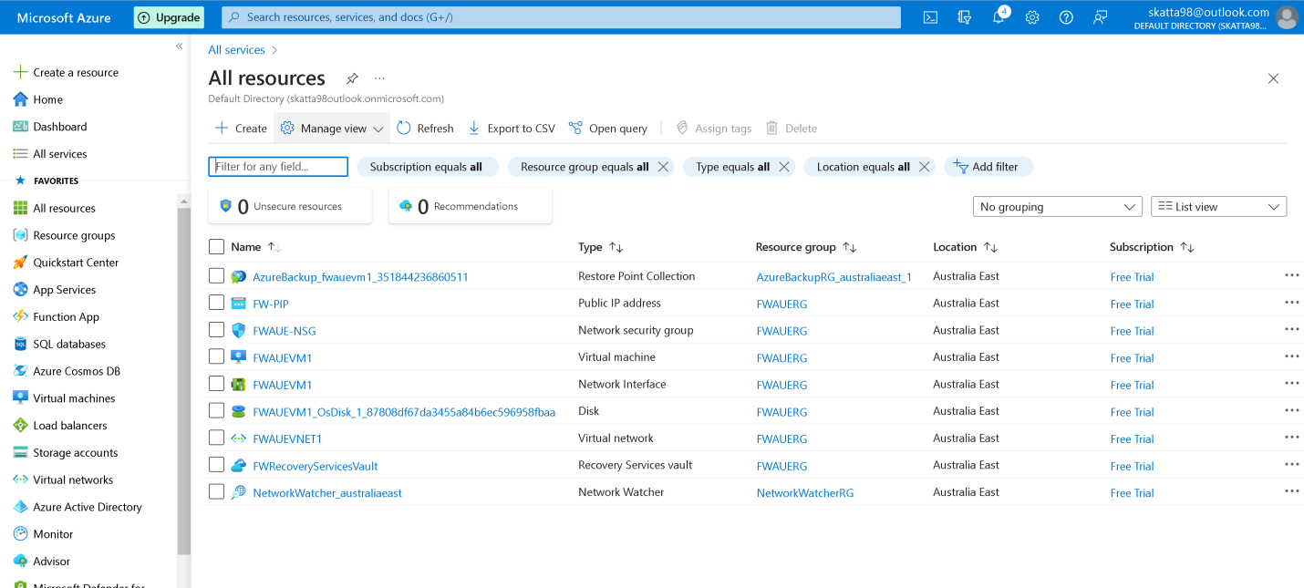

**#Register Recovery Services**

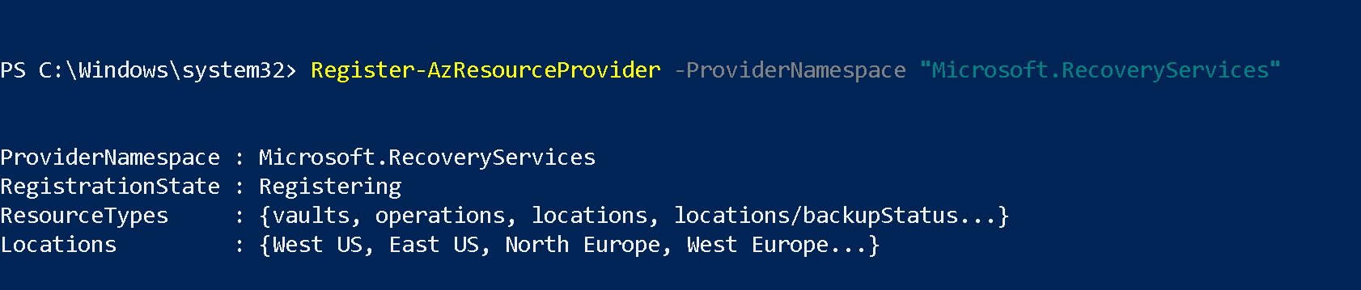

**#Creates Backup Vault**

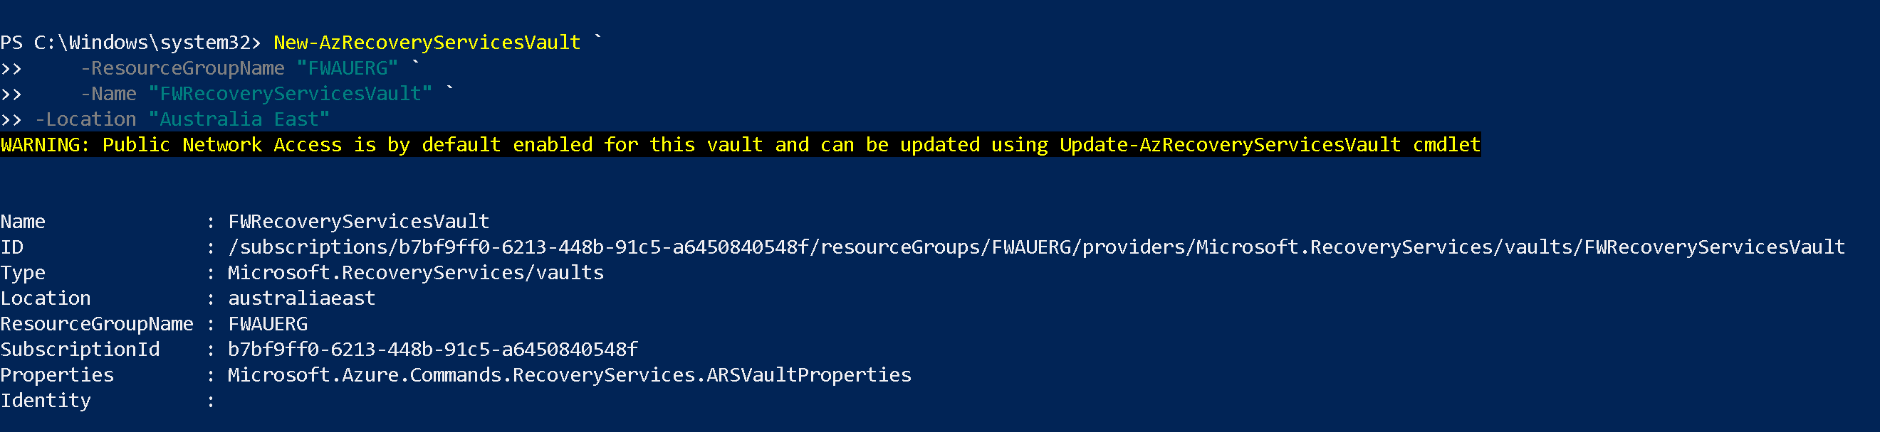

**# Set Context**

**# Assign the FW-Backup Policy to the variable**

**# Have Created a new Backup Policy to have Daily, Weekly and monthly backups called "FW-BackupPolicy"**

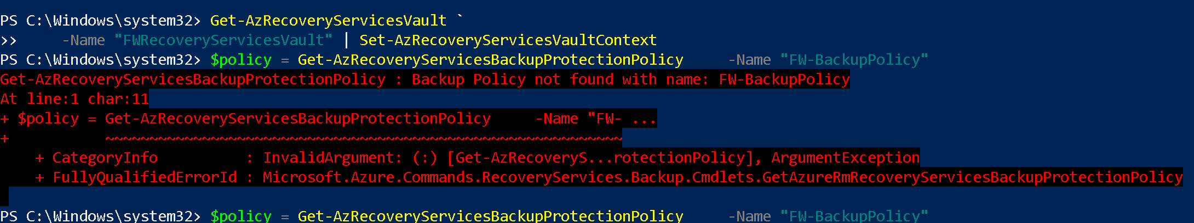

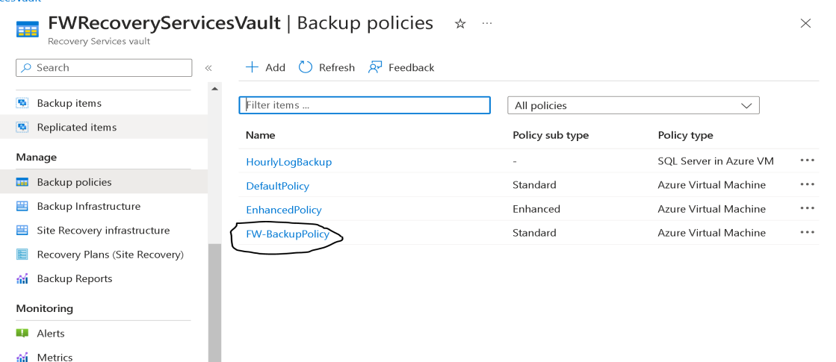

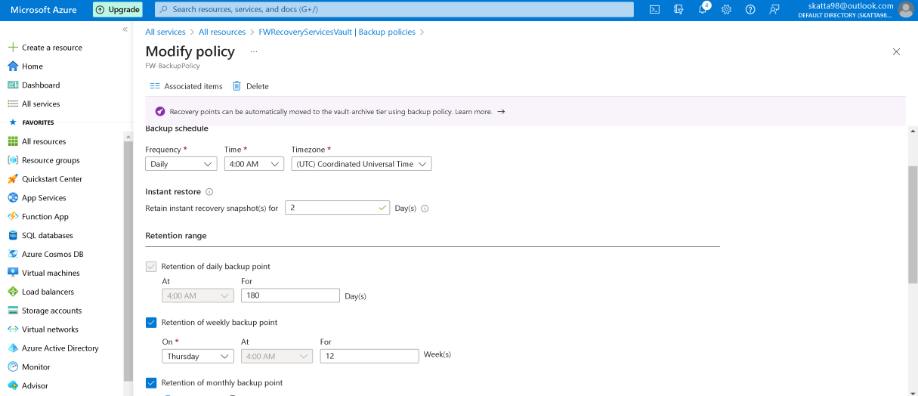

**#Enables Backup**

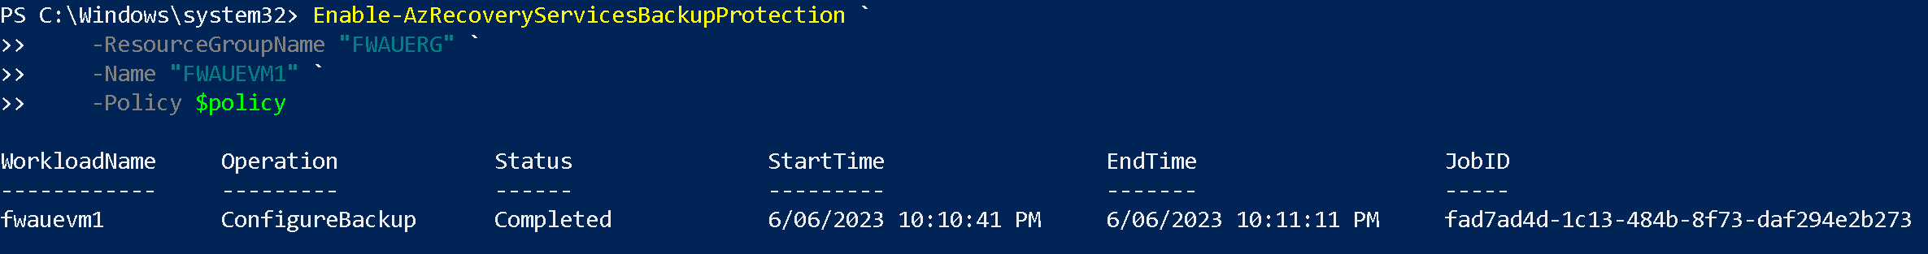

**#Triggers Backup**

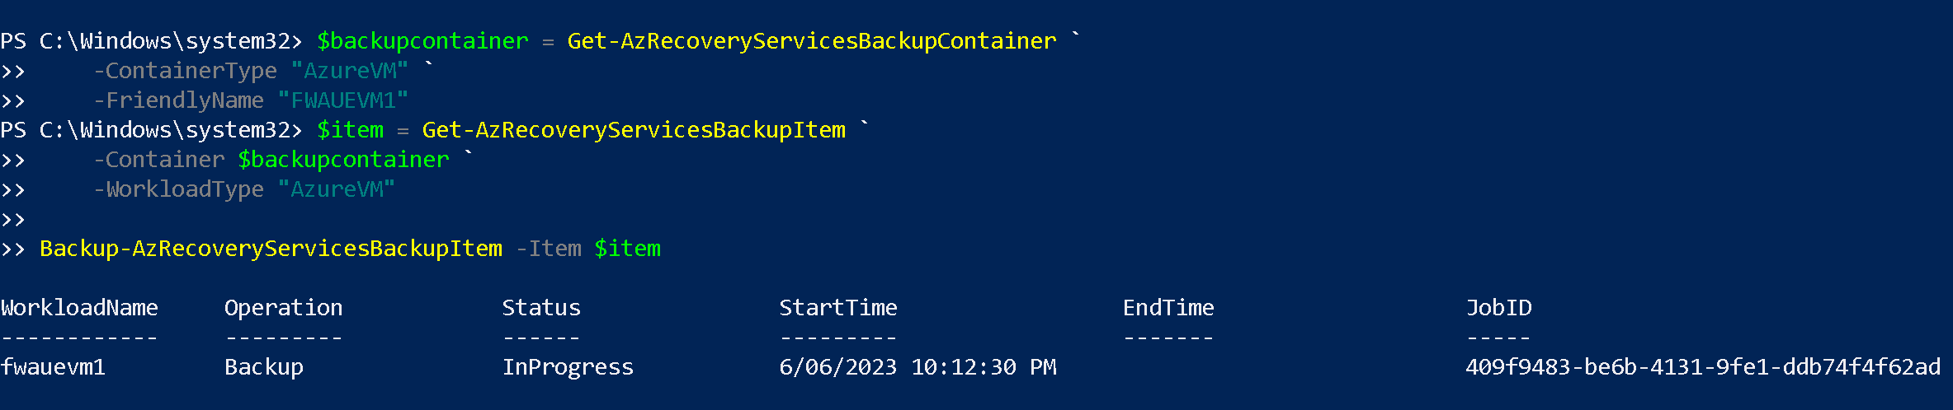

**# Monitors the Backup Job**

